**You can select the “Giga-CE Help” button to pull up these instructions from within GigaCE.**

Launch GigaCE analysis program

1. On the desktop open “Anaconda Prompt (Miniconda3)”

* 1. A black window will open up that should say “(base) C:\Users\Allbritton Lab Desk” into this window enter the following (you can copy and paste these commands):
     1. cd C:\Users\Allbritton Lab Desk\GiGa-CE
        1. The command “cd” changes the directory, and then the address after “cd” is where the GigaCE program folder is located. Essentially we are telling python where the program we want to run is located
     2. conda activate GigaCE
        1. In anaconda I created an environment that has all the components that must be loaded to run GigaCE. This command tells python to use that pre-created environment
     3. python main.py
        1. This is telling python to run the main GigaCE program and start the program you’re familiar with
  2. It will take a couple of seconds, sometimes 10 or more, but a small window will pop up that asks for you to “Enter User Name”. Depending on how many people are using the computer, you can just enter in your first name as your userename, but make sure to be consistent with the name being entered from session to session.
  3. Click “Start GigaCE” and you will be in the program.
     1. Of note, the scroll wheel/trackpad scroll won’t work but dragging the scroll bar on the side of the program will move the screen as needed

1. Using GigaCE
   1. Importing new separation data
      1. Click “Main menu” button in the bottom right
      2. Click “Go to Separations”
      3. Click “Analyze new separations”
      4. Navigate to the new data for that day that you want to analyze
      5. Select all the files for that day and click open, be sure to only select ASC file type as that is what GigaCE intakes from the MDQs (also is able to take in .csv as well)
      6. The files will now be sorted by the date that you’ve imported them
   2. Analyzing the electropherograms
      1. Setting the baseline (for an individual separation)
         1. Click on a separation to be analyzed
         2. Check the box next to “poly baseline”
         3. In the box directly below on the left change the number to the desired polynomial degree for the baseline fit (often 1)
         4. Click “Save Edits” (next to the “set injection volume” button)
         5. When you reselect a separation you should see something like this:

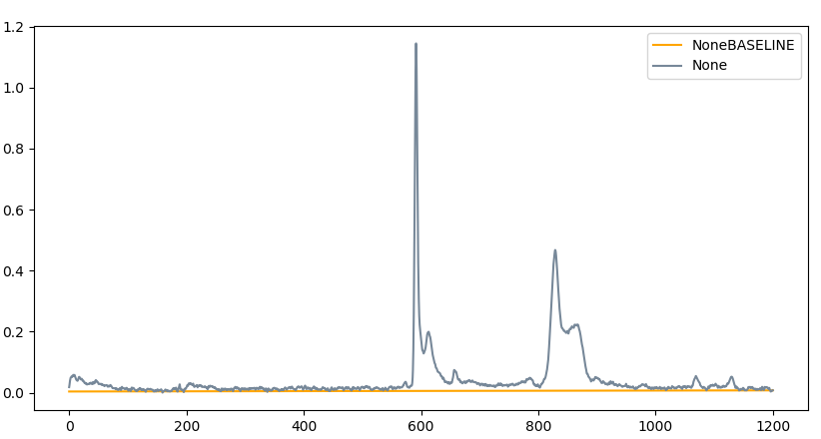

* + - 1. If you would like to autopopulate baselines to multiple separations:
         1. Check the boxes next to “Poly Baseline” and “Autopopulate Poly Baseline to Session”, enter in below the Degrees on the left and the First Data to Skip on the right, then click “Save Edits”.
         2. If you need to override a specific separation, repeat the same steps with “Poly Baseline” checked but “Autopopulate Poly Baseline to Session” not checked, then repeat step a to re-autopopulate for the rest of the separations.
         3. **Note:** further instructions for the functionality when different combinations of these two boxes (“Poly Baseline” and “Autopopulate Poly Baseline to Session”), are checked can be found in Megan’s GigaCE Improvement Summary, but these functionalities are subject to change with some future improvements.
    1. Measuring the peaks
       1. Select a separation and click the “Add Peak” button on the bottom right to add the relevant number of peaks to the separations
          1. These should pop up in the lower window
       2. Repeat for all separations
       3. Select a separation
       4. In the lower window select one of the unnamed peaks
       5. In the empty “name” box enter the name for the peak (e.g. SF, S1PF, Fl, etc.)
       6. Setting the width of a peak
          1. Click on the electropherogram graph on either side of your peak of interest. Click “Set Width:
          2. Example: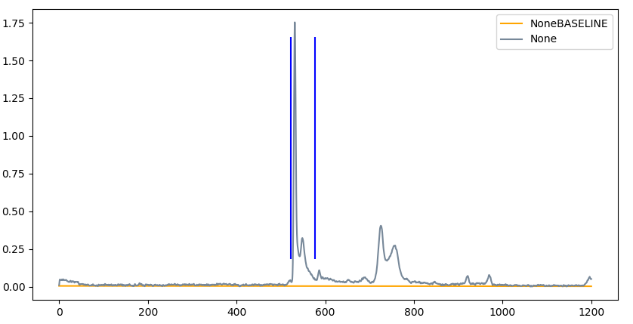

**Make sure to be consistent in how you set the width of a peak** to either always include or always exclude any minor peaks that could be part of the peak. This is extra important because any additional peak area can significantly shift our results.

* + - * 1. Click “Save Peak Edits” (just above the peak window)

You should see one of the peaks change to the assigned name

You can click on the peak to see the peak area you’ve selected and you can go back and edit it if needed

* + - * 1. Go through the rest of the separations repeating steps a-c from above
      1. If you would like to set peaks for multiple separations at a time when samples are run multiple times and therefore have very similar peaks:
         1. Select/highlight the separations that you would like to add a peak in the same location.

Use “shift+left click” to select a continuous group of separations

Use “ctrl + left click” to select additional separations individually

* + - * 1. Click “Add Peak”, which will add one peak to each separation highlighted.
        2. Select/highlight the peaks that you would like to define the same area for (for example, if an experiment was run multiple times and therefore the peaks appear in the approximately same position).
        3. In the empty “name” box enter the name for the peak (e.g. SF, S1PF, Fl, etc.). This name will be assigned to every peak that is selected.
        4. Click on the electropherogram graph on either side of your peak of interest.
        5. Click “Set Width”.
        6. Click “Save Peak Edits”. The peak width will now be assigned to every peak that was highlighted.
        7. If needed, the user can go in and edit any peaks that seem incorrect.
        8. **Note:** This chooses a peak in the same location, but it does not adjust for different locations of peaks. Therefore, this method of selecting multiple peaks is most helpful when the peaks are from the same sample and the peaks from different runs are very overlapping.
  1. Exporting the peak areas and electropherograms
     1. Click on the electropherograms you want to export
        1. Use “shift+left click” to select a continuous group of electropherograms
        2. Use “ctrl + left click” to select additional electropherograms individually
     2. On the bottom left of the program (will likely need to move the scroll bar on the right side of the program) click “export electropherograms”
        1. Title this file as “Collected electropherograms mm-dd-yyyy A/B”
           1. The A or B is selected based on which MDQ the electropherograms were collected on
     3. If peak areas were analyzed click “export peak areas”
        1. Title this file as “Collected peak areas mm-dd-yyyy A/B”